W228A/103C, W228B/103C



DUBLIN INSTITUTE OF TECHNOLOGY
_____________

DT228A/1 MSc in Computing
DT228B/1 MSc in Computing
DT228B/2 MSc in Computing
______________

WINTER EXAMINATIONS 2017/2018
______________

Probability and Statistical Inference [Math9102]

Ms. Deirdre Lawless
Dr. Deirdre Lillis
Dr. Ignacio Castiñeiras

Date & Time TBA

Two Hours

Instructions to candidates

Answer question one and one other question.

All questions carry equal marks.

Description of Dataset to be used in All Questions

The General Social Survey (GSS) regularly gathers data on American society to monitor trends in attitudes and behaviours in society. The dataset used in this exam paper is a subset of one year of the GSS. The variables of interest to the questions in this paper are shown in the table below.

Name | Label | Values | Type
AGE | Respondent age |  | Scale
GENDER | Respondent gender | 1 MALE; 2 FEMALE | Nominal
MARTIAL | Marital Status | 1 MARRIED; 2 WIDOWED; 3 DIVORCED; 4 SPEARATED; 5 NEVER MARRIED | Nominal
FAMINCOME | Family Income | Values represent income bands | Scale
HRSWRKD | Hours Worked Last Week |  | Scale
HRSRELAX | Hours Per Day ‎Respondent Has To Relax |  | Scale
i1_immameco | IMMIGRANTS ARE GOOD FOR AMERICA | 1 AGREE STRONGLY; 2 AGREE; 3 NEITHER AGREE or DISAGREE; 4 DISAGREE; 5 DISAGREE STRONGLY | Ordinal
i2_immcult | IMMIGRANTS UNDERMINE AMERICAN CULTURE |  | Ordinal
i3_immideas | IMMIGRANTS MAKE AMERICA MORE OPEN |  | Ordinal
i4_immjobs | IMMIGRANTS TAKE JOBS AWAY |  | Ordinal
i5_immrghts | LEGAL IMMIGRANTS SHOULD HAVE SAME RIGHTS AS AMERICANS |  | Ordinal
i6_excldimm | AMERICA SHOULD EXCLUDE ILLEGAL IMMIGRANTS |  | Ordinal
i7_letin1 | NUMBER OF IMMIGRANTS TO AMERICA NOWADAYS SHOULD BE RESTRICTED |  | Ordinal
i8_meltpot1 | BETTER TO MAINTAIN DISTINCT CULTURES |  | Ordinal

1. | (a) | Providing a statistical summary of the scale variables of interest including a measure central tendency, dispersion and in particular skewness and kurtosis is helpful when presenting a statistical analysis.  Explain each of these concepts and how together what they allow you to describe for variables of interest.  Illustrate your answer by presenting a statistical summary of the variables related to family income, hours per day to relax and hours worked last week using appropriate measures selected from the information provided in Appendix A.  Draw conclusions about their normality.  (18 marks)
 | (b) | Explain what Type I and Type II errors are, how they occur and how to avoid them.  (8 marks)

 | (c) | Suppose the research team wants to investigate factors that influence family income. Existing research has shown it is influenced by the amount of time a person spends working and their age but that there are differences in income for respondents of different gender and marital status. They now wish to test this theory against the data collected in the GSS.  Explain the steps that you would need to take to develop and test hypotheses related to this theory.  Illustrate your answer by deriving and testing hypotheses related to the team’s theory using the statistics provided in in Appendix A.  Justify your selection of statistical tests based on your answer to part (a).  (24 marks)

2. | (a) | The research team has decided to further explore the relationship between the family income of a respondent, the hours they worked last week, their age and gender. They have standardised family income, hours worked last week and age. Gender has been recoded as 0 for male and 1 for female. A multiple linear regression model has been created and the relevant statistics are provided in Appendix B.  Explain what linear regression could allow the research team to achieve in terms of their research. In your answer you should clearly explain the following:  - What regression will allow the researcher to do;  - What prediction means in this context;  - Why standardising the scale variables is useful;  - The type of variable used to include gender in the model and why it is needed.  (14 marks)
 | (b) | For the model created in part (a):  - Assess the fit and usefulness of the model created.  (12 marks)  - Explain how to interpret the model for male and female respondents.  (10 marks)  In your answer you should state the regression equation, clearly explain any concepts or statistics to which you refer. Illustrate your answers by using the statistics included in Appendix B.
 | (c) | The research team decided to investigate whether there is an interaction effect between age and gender. They have created a variable IntGenAge, a combination of standardised score for age and gender recoded, and included this in the regression model created for part (b). The output is shown in Appendix B.  - Discuss what an interaction effect is and how it can be assessed using multiple linear regression.  (4 marks)  - Evaluate this model for male and female respondents.  (4 marks)  - Comment on the change in the fit of the model compared to that created in part (a) and how the new term affects the coefficients.  In your answer you should state the regression equation and illustrate your answers by using the statistics included in Appendix B.  (6 marks)

3. |  | The research team is interested in respondent’s attitude towards immigration. This is currently assed using eight variables in the dataset resulting from a respondent’s answers to Likert style questions (i1_immameco, i2_immcult, i3_immideas, i4_immjobs, i5_immrghts, i6_excldimm, i7_letin1, i8_meltpot1).  The team want to use Exploratory Factor Analysis to see if it is possible derive a composite score for a respondent’s attitude towards immigration which they could then use as part of a multiple linear regression.  Explain what Exploratory Factor Analysis will allow the research team to achieve.  Discuss the suitability of the dataset for use with this approach.  Illustrate your answer by referring to the statistics included in Appendix C.  You should clearly explain any concepts or statistics to which you refer.  (18 marks)
 | (b) | Discuss the outcomes of the application of exploratory factor analysis to the dataset and assess its effectiveness for the purposes of the research team.  (20 marks)  In your answers you should clearly explain any concepts or statistics to which you refer. Illustrate your answers by referring to the statistics included in Appendix C.
 | (c) | Suppose the first factor extracted during exploratory factor analysis has been saved to the dataset as posimm (Positive attitude to immigration) and that the research team has built a multiple linear regression model with this variable as the dependent variable and the standardised scores for family income, age and gender (recoded as 0 and 1) as independent variables.  Assess the fit and usefulness of the model created.  Illustrate your answer by reference to the statistics provided for the variables of interest in Appendix C.  (12 marks)

 | 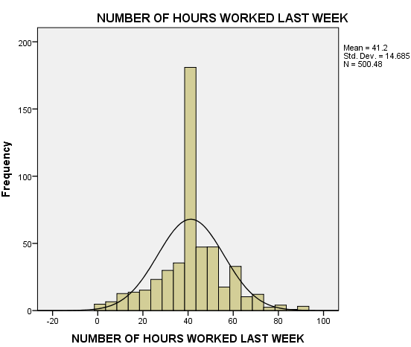
  NUMBER OF HOURS WORKED LAST WEEK |  | HOURS PER DAY ‎RESPONDENT HAS TO RELAX | TOTAL FAMILY INCOME
  N | Valid | 500 | 409 | 702
  N | Missing | 282 | 373 | 80
  Mean |  | 41.20 | 3.39 | 17.75
  Std. Deviation |  | 14.685 | 2.334 | 5.605
  Skewness |  | 0.020 | 1.338 | -1.029
  Std. Error of Skewness |  | 0.109 | 0.121 | 0.092
  Kurtosis |  | 1.058 | 4.183 | 0.704
  Std. Error of Kurtosis |  | 0.218 | 0.241 | 0.184
  Percentiles | 25 | 37.00 | 2.00 | 15.00
  Percentiles | 50 | 40.00 | 3.00 | 19.00
  Percentiles | 75 | 50.00 | 5.00 | 22.00
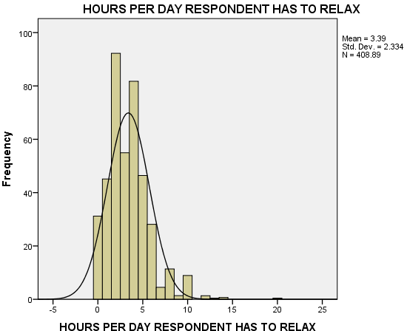 | 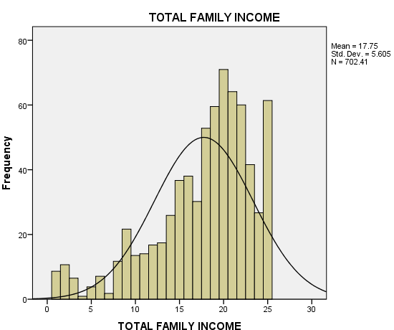

Zscore TOTAL FAMILY INCOME Stem-and-Leaf Plot  Frequency Stem & Leaf  8.38 Extremes (=<-2.1)  1.34 -1 . 99  3.14 -1 . 7777  8.79 -1 . 55555555555  12.82 -1 . 2222223333333333  9.97 -1 . 000000000000  6.96 -0 . 888888888  9.28 -0 . 666666666666  19.93 -0 . 4444444444444444444444444  22.00 -0 . 333333333333333333333333333  13.38 -0 . 11111111111111111  34.00 0 . 000000000000000000000000000000000000000000  28.96 0 . 222222222222222222222222222222222222  80.15 0 . 4444444444444444444444444444444444444444444444444  444444444455555555555555555555555555555555555555555  36.52 0 . 7777777777777777777777777777777777  777777777777  24.93 0 . 9999999999999999999999999999999  12.34 1 . 111111111111111  49.67 1 . 2222222222222222222222222222222222222222222222222  2222222222222  Stem width: 1.00000 Each leaf: .80 case(s) | Zscore NUMBER OF HOURS WORKED LAST WEEK Stem-and-Leaf Plot  Frequency Stem & Leaf  24.76 Extremes (=<-1.7)  10.00 -1 . 44444&  1.83 -1 . 2  11.93 -1 . 000011  10.41 -0 . 888899  21.93 -0 . 66677777777  10.83 -0 . 44445  18.49 -0 . 222333333  131.89 -0 . 111111111111111111111111111111111111111111111111111111111111111111&  7.00 0 . 001  24.07 0 . 222222222222&  36.69 0 . 444555555555555555  6.59 0 . 666  12.07 0 . 888889  3.86 1 . 00  26.80 1 . 2222222222222  3.86 1 . 55  .90 1 . &  18.66 Extremes (>=1.9)  Stem width: 1.00000  Each leaf: 2 case(s)  & denotes fractional leaves.
Zscore HOURS PER DAY ‎RESPONDENT HAS TO RELAX Stem-and-Leaf Plot
Frequency Stem & Leaf
31.18 -1 . 44444444444444444444444444444444444444
42.87 -1 . 00000000000000000000000000000000000000000000
00000000
83.59 -0 . 6666666666666666666666666666666666666666666666666
6666666666666666666666666666666666666666666666666666
52.72 -0 . 111111111111111111111111111111111111111111111
1111111111111111111
79.07 0 . 222222222222222222222222222222222222222222222
222222222222222222222222222222222222222222222222222
41.66 0 . 66666666666666666666666666666666666666666666666666
22.38 1 . 000000000000000000000000000
4.48 1 . 44444
24.63 Extremes (>=1.9)
Stem width: 1.00000 Each leaf: .83 case(s)

Pearson
  AGE OF RESPONDENT |  | TOTAL FAMILY INCOME | NUMBER OF HOURS WORKED LAST WEEK
  AGE OF RESPONDENT | Pearson Correlation | 1 | .134** | 0.038
  AGE OF RESPONDENT | Sig. (2-tailed) |  | 0.000 | 0.394
  AGE OF RESPONDENT | N | 781 | 702 | 500
  TOTAL FAMILY INCOME | Pearson Correlation | .134** | 1 | .278**
  TOTAL FAMILY INCOME | Sig. (2-tailed) | 0.000 |  | 0.000
  TOTAL FAMILY INCOME | N | 702 | 702 | 465
  NUMBER OF HOURS WORKED LAST WEEK | Pearson Correlation | 0.038 | .278** | 1
  NUMBER OF HOURS WORKED LAST WEEK | Sig. (2-tailed) | 0.394 | 0.000
  NUMBER OF HOURS WORKED LAST WEEK | N | 500 | 465 | 500
  **. Correlation is significant at the 0.01 level (2-tailed).
  Spearman's Rho |  | AGE OF RESPONDENT | TOTAL FAMILY INCOME | NUMBER OF HOURS WORKED LAST WEEK
  AGE OF RESPONDENT | Correlation Coefficient | 1.000 | .164** | 0.056
  AGE OF RESPONDENT | Sig. (2-tailed) |  | 0.000 | 0.236
  AGE OF RESPONDENT | N | 692 | 621 | 449
  TOTAL FAMILY INCOME | Correlation Coefficient | .164** | 1.000 | .270**
  TOTAL FAMILY INCOME | Sig. (2-tailed) | 0.000 |  | 0.000
  TOTAL FAMILY INCOME | N | 621 | 621 | 420
  NUMBER OF HOURS WORKED LAST WEEK | Correlation Coefficient | 0.056 | .270** | 1.000
  NUMBER OF HOURS WORKED LAST WEEK | Sig. (2-tailed) | 0.236 | 0.000
  NUMBER OF HOURS WORKED LAST WEEK | N | 449 | 420 | 450
Group Statistics
RESPONDENTS SEX |  | N | Mean | Std. Deviation | Std. Error Mean
TOTAL FAMILY INCOME | MALE | 321 | 17.94 | 5.491 | 0.306
TOTAL FAMILY INCOME | FEMALE | 381 | 17.59 | 5.701 | 0.292

Independent Samples Test
 |  | Levene's Test for Equality of Variances |  | t-test for Equality of Means
 |  | F | Sig. | t | df | Sig. (2-tailed) | Mean Difference | Std. Error Difference | 95% Confidence Interval of the Difference
 |  |  |  |  |  |  |  |  | Lower | Upper
TOTAL FAMILY INCOME | Equal variances assumed | 0.473 | 0.492 | 0.837 | 700 | 0.403 | 0.355 | 0.425 | -0.478 | 1.189
TOTAL FAMILY INCOME | Equal variances not assumed |  |  | 0.840 | 688.183 | 0.401 | 0.355 | 0.423 | -0.475 | 1.186

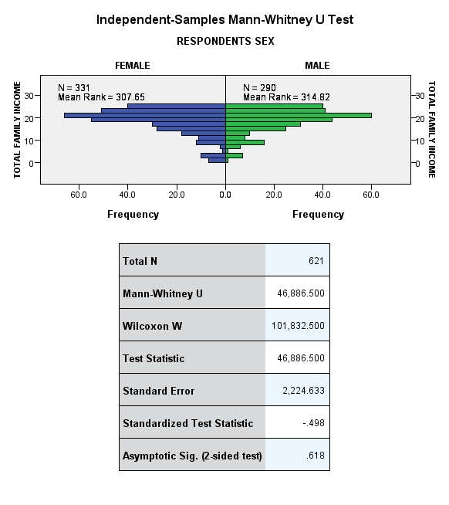 | 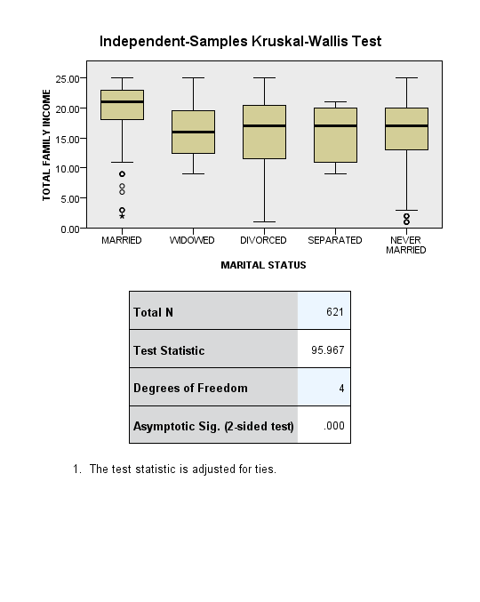

ANOVA
  TOTAL FAMILY INCOME
  Mean SquareFSig.
  Between GroupsSum of Squaresdf | 3639.798 | 4 | 909.949 | 34.483 | 0.000
  Within Groups | 18392.726 | 697 | 26.388
  Total | 22032.523 | 701
  Multiple Comparisons
  Dependent Variable:
  Tukey HSD
  (I) MARITAL STATUS |  | Mean Difference (I-J) | Std. Error | Sig. | 95% Confidence Interval
   |  |  |  |  | Lower Bound | Upper Bound
  MARRIED | WIDOWED | 4.297* | 0.878 | 0.000 | 1.90 | 6.70
  MARRIED | DIVORCED | 4.143* | 0.575 | 0.000 | 2.57 | 5.72
  MARRIED | SEPARATED | 5.622* | 1.495 | 0.002 | 1.53 | 9.71
  MARRIED | NEVER MARRIED | 4.718* | 0.462 | 0.000 | 3.45 | 5.98
  WIDOWED | MARRIED | -4.297* | 0.878 | 0.000 | -6.70 | -1.90
  WIDOWED | DIVORCED | -0.154 | 0.978 | 1.000 | -2.83 | 2.52
  WIDOWED | SEPARATED | 1.325 | 1.691 | 0.935 | -3.30 | 5.95
  WIDOWED | NEVER MARRIED | 0.421 | 0.915 | 0.991 | -2.08 | 2.93
  DIVORCED | MARRIED | -4.143* | 0.575 | 0.000 | -5.72 | -2.57
  DIVORCED | WIDOWED | 0.154 | 0.978 | 1.000 | -2.52 | 2.83
  DIVORCED | SEPARATED | 1.479 | 1.556 | 0.877 | -2.78 | 5.73
  DIVORCED | NEVER MARRIED | 0.575 | 0.631 | 0.893 | -1.15 | 2.30
  SEPARATED | MARRIED | -5.622* | 1.495 | 0.002 | -9.71 | -1.53
  SEPARATED | WIDOWED | -1.325 | 1.691 | 0.935 | -5.95 | 3.30
  SEPARATED | DIVORCED | -1.479 | 1.556 | 0.877 | -5.73 | 2.78
  SEPARATED | NEVER MARRIED | -0.904 | 1.517 | 0.976 | -5.05 | 3.25
  NEVER MARRIED | MARRIED | -4.718* | 0.462 | 0.000 | -5.98 | -3.45
  NEVER MARRIED | WIDOWED | -0.421 | 0.915 | 0.991 | -2.93 | 2.08
  NEVER MARRIED | DIVORCED | -0.575 | 0.631 | 0.893 | -2.30 | 1.15
  NEVER MARRIED | SEPARATED | 0.904 | 1.517 | 0.976 | -3.25 | 5.05
  *. The mean difference is significant at the 0.05 level.

  Model Summary
  Model | R | R Square | Adjusted R Square | Std. Error of the Estimate
  1 | .328ª | 0.108 | 0.102 | 0.81323684
  a. Predictors: (Constant), Zscore: AGE OF RESPONDENT, Zscore: NUMBER OF HOURS WORKED LAST WEEK, GENDER RECODED
  ANOVAª
  Model |  | Sum of Squares | df | Mean Square | F | Sig.
  1 | Regression | 36.743 | 3 | 12.248 | 18.519 | .000^{b}
  1 | Residual | 304.703 | 461 | 0.661
  1 | Total | 341.446 | 464
  a. Dependent Variable: Zscore: TOTAL FAMILY INCOME
  b. Predictors: (Constant), Zscore: AGE OF RESPONDENT, Zscore: NUMBER OF HOURS WORKED LAST WEEK, GENDER RECODED
Coefficientsª
Model |  | Unstandardized Coefficients |  | Standardized Coefficients | t | Sig.
 |  | B | Std. Error | Beta | t | Sig.
1 | (Constant) | 0.205 | 0.054 |  | 3.812 | 0.000
1 | Zscore: NUMBER OF HOURS WORKED LAST WEEK | 0.254 | 0.040 | 0.285 | 6.404 | 0.000
1 | GENDER RECODED | 0.092 | 0.076 | 0.054 | 1.204 | 0.229
1 | Zscore: AGE OF RESPONDENT | 0.188 | 0.050 | 0.166 | 3.768 | 0.000
a. Dependent Variable: Zscore: TOTAL FAMILY INCOME

  Model Summary
  Model | R | R Square | Adjusted R Square | Std. Error of the Estimate
  1 | .329ª | 0.108 | 0.101 | 0.81382174
  a. Predictors: (Constant), INTERACTION AGE AND GENDER, Zscore: NUMBER OF HOURS WORKED LAST WEEK, GENDER RECODED, Zscore: AGE OF RESPONDENT
  ANOVAª
  Model |  | Sum of Squares | df | Mean Square | F | Sig.
  1 | Regression | 36.967 | 4 | 9.242 | 13.954 | .000^{b}
  1 | Residual | 304.479 | 460 | 0.662
  1 | Total | 341.446 | 464
  a. Dependent Variable: Zscore: TOTAL FAMILY INCOME
  b. Predictors: (Constant), INTERACTION AGE AND GENDER, Zscore: NUMBER OF HOURS WORKED LAST WEEK, GENDER RECODED, Zscore: AGE OF RESPONDENT
Coefficientsª
Model |  | Unstandardized Coefficients |  | Standardized Coefficients | t | Sig.
 |  | B | Std. Error | Beta | t | Sig.
1 | (Constant) | 0.199 | 0.054 |  | 3.659 | 0.000
1 | Zscore: NUMBER OF HOURS WORKED LAST WEEK | 0.252 | 0.040 | 0.283 | 6.344 | 0.000
1 | GENDER RECODED | 0.102 | 0.078 | 0.060 | 1.304 | 0.193
1 | Zscore: AGE OF RESPONDENT | 0.160 | 0.069 | 0.141 | 2.313 | 0.021
1 | INTERACTION AGE AND GENDER | 0.058 | 0.100 | 0.036 | 0.581 | 0.561
a. Dependent Variable: Zscore: TOTAL FAMILY INCOME

** significant at p <.001, * significant at p <0.05
  Correlation Matrixª
   |  | IMMIGRANTS GOOD FOR AMERICA | IMMIGRANTS UNDERMINE AMERICAN CULTURE | IMMIGRANTS MAKE AMERICA MORE OPEN | IMMIGRANTS TAKE JOBS AWAY | LEGAL IMMIGRANTS SHOULD HAVE SAME RIGHTS AS AMERICANS | AMERICA SHOULD EXCLUDE ILLEGAL IMMIGRANTS | NUMBER OF IMMIGRANTS TO AMERICA NOWADAYS SHOULD BE RESTRICTED | BETTER TO MAINTAIN DISTINCT CULTURES
  Correlation | IMMIGRANTS GOOD FOR AMERICA | 1.000 | -0.283** | 0.588** | -0.489** | 0.239** | -0.247** | 0.405** | 0.129*
  Correlation | IMMIGRANTS UNDERMINE AMERICAN CULTURE | -0.283** | 1.000 | -0.281** | 0.363** | -0.067 | 0.176** | -0.221** | -0.137*
  Correlation | IMMIGRANTS MAKE AMERICA MORE OPEN | 0.588** | -0.281** | 1.000 | -0.443** | 0.244** | -0.282** | 0.429** | 0.093
  Correlation | IMMIGRANTS TAKE JOBS AWAY | -0.489** | 0.363** | -0.443** | 1.000 | -0.180** | 0.273** | -0.357** | -0.083
  Correlation | LEGAL IMMIGRANTS SHOULD HAVE SAME RIGHTS AS AMERICANS | 0.239** | -0.067 | 0.244** | -0.180** | 1.000 | -0.303** | 0.273** | 0.136**
  Correlation | AMERICA SHOULD EXCLUDE ILLEGAL IMMIGRANTS | -0.247** | 0.176** | -0.282** | 0.273** | -0.303** | 1.000 | -0.336** | -0.245**
  Correlation | NUMBER OF IMMIGRANTS TO AMERICA NOWADAYS SHOULD BE RESTRICTED | 0.405** | -0.221** | 0.429** | -0.357** | 0.273** | -0.336** | 1.000 | 0.125*
  Correlation | BETTER TO MAINTAIN DISTINCT CULTURES | 0.129* | -0.137* | 0.093 | -0.083 | 0.136** | -0.245** | 0.125* | 1.000
  Determinant = .204_{a}
  KMO and Bartlett's Test
  Kaiser-Meyer-Olkin Measure of Sampling Adequacy. |  | 0.815
  Bartlett's Test of Sphericity | Approx. Chi-Square | 464.112
  Bartlett's Test of Sphericity | df | 28
  Bartlett's Test of Sphericity | Sig. | 0.000
 | 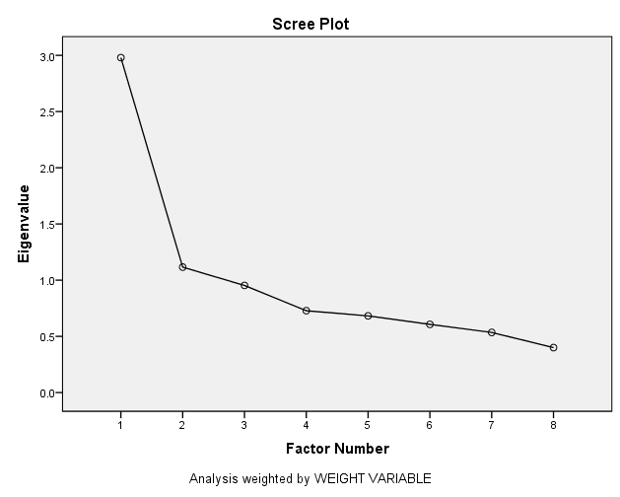
  Communalities
   | Initial | Extraction
  IMMIGRANTS GOOD FOR AMERICA | 0.432 | 0.582
  IMMIGRANTS UNDERMINE AMERICAN CULTURE | 0.168 | 0.173
  IMMIGRANTS MAKE AMERICA MORE OPEN | 0.420 | 0.540
  IMMIGRANTS TAKE JOBS AWAY | 0.340 | 0.425
  LEGAL IMMIGRANTS SHOULD HAVE SAME RIGHTS AS AMERICANS | 0.146 | 0.194
  AMERICA SHOULD EXCLUDE ILLEGAL IMMIGRANTS | 0.220 | 0.515
  NUMBER OF IMMIGRANTS TO AMERICA NOWADAYS SHOULD BE RESTRICTED | 0.286 | 0.356
  BETTER TO MAINTAIN DISTINCT CULTURES | 0.077 | 0.107
  Extraction Method: Principal Axis Factoring.
Total Variance Explained
Factor | Initial Eigenvalues |  |  | Extraction Sums of Squared Loadings |  |  | Rotation Sums of Squared Loadings
Factor | Total | % of Variance | Cumulative % | Total | % of Variance | Cumulative % | Total | % of Variance | Cumulative %
1 | 2.980 | 37.248 | 37.248 | 2.417 | 30.212 | 30.212 | 1.896 | 23.696 | 23.696
2 | 1.116 | 13.948 | 51.196 | 0.476 | 5.950 | 36.162 | 0.997 | 12.466 | 36.162
3 | 0.953 | 11.912 | 63.108
4 | 0.728 | 9.101 | 72.209
5 | 0.682 | 8.525 | 80.734
6 | 0.607 | 7.582 | 88.316
7 | 0.535 | 6.685 | 95.001
8 | 0.400 | 4.999 | 100.000
Extraction Method: Principal Axis Factoring.

  Factor Matrixª
   | Factor
   | 1 | 2
  IMMIGRANTS GOOD FOR AMERICA | 0.725 | 0.236
  IMMIGRANTS UNDERMINE AMERICAN CULTURE | -0.407 | -0.086
  IMMIGRANTS MAKE AMERICA MORE OPEN | 0.712 | 0.182
  IMMIGRANTS TAKE JOBS AWAY | -0.633 | -0.159
  LEGAL IMMIGRANTS SHOULD HAVE SAME RIGHTS AS AMERICANS | 0.377 | -0.228
  AMERICA SHOULD EXCLUDE ILLEGAL IMMIGRANTS | -0.522 | 0.492
  NUMBER OF IMMIGRANTS TO AMERICA NOWADAYS SHOULD BE RESTRICTED | 0.593 | -0.066
  BETTER TO MAINTAIN DISTINCT CULTURES | 0.226 | -0.237
  Extraction Method: Principal Axis Factoring.
  a. 2 factors extracted. 25 iterations required.
  Rotated Factor Matrixª
   | Factor
   | 1 | 2
  IMMIGRANTS GOOD FOR AMERICA | 0.743 | 0.174
  IMMIGRANTS UNDERMINE AMERICAN CULTURE | -0.393 | -0.138
  IMMIGRANTS MAKE AMERICA MORE OPEN | 0.703 | 0.214
  IMMIGRANTS TAKE JOBS AWAY | -0.623 | -0.192
  LEGAL IMMIGRANTS SHOULD HAVE SAME RIGHTS AS AMERICANS | 0.205 | 0.390
  AMERICA SHOULD EXCLUDE ILLEGAL IMMIGRANTS | -0.192 | -0.691
  NUMBER OF IMMIGRANTS TO AMERICA NOWADAYS SHOULD BE RESTRICTED | 0.473 | 0.364
  BETTER TO MAINTAIN DISTINCT CULTURES | 0.070 | 0.320
  Extraction Method: Principal Axis Factoring.
  Rotation Method: Varimax with Kaiser Normalization.
  a. Rotation converged in 3 iterations.

  Model Summary
  Model | R | R Square | Adjusted R Square | Std. Error of the Estimate
  1 | .251ª | 0.063 | 0.053 | 0.83110348
  a. Predictors: (Constant), Zscore: AGE OF RESPONDENT, GENDER RECODED, Zscore: TOTAL FAMILY INCOME
  ANOVAª
  Model |  | Sum of Squares | df | Mean Square | F | Sig.
  1 | Regression | 12.361 | 3 | 4.120 | 5.965 | .001^{b}
  1 | Residual | 183.533 | 266 | 0.691
  1 | Total | 195.894 | 269
  a. Dependent Variable: POSITIVE ATTITUDE TO IMMIGRATION
  b. Predictors: (Constant), Zscore: AGE OF RESPONDENT, GENDER RECODED, Zscore: TOTAL FAMILY INCOME
Coefficientsª
Model |  | Unstandardized Coefficients |  | Standardized Coefficients | t | Sig.
 |  | B | Std. Error | Beta | t | Sig.
1 | (Constant) | -0.174 | 0.077 |  | -2.256 | 0.025
1 | GENDER RECODED | 0.318 | 0.102 | 0.185 | 3.112 | 0.002
1 | Zscore: TOTAL FAMILY INCOME | -0.151 | 0.054 | -0.168 | -2.823 | 0.005
1 | Zscore: AGE OF RESPONDENT | 0.003 | 0.053 | 0.004 | 0.063 | 0.950
a. Dependent Variable: POSITIVE ATTITUDE TO IMMIGRATION

